Q1. Create a new branch ‘js-assignments’.

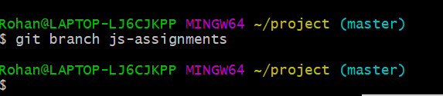

Q2. Switch to ‘js-assignments’ branch.

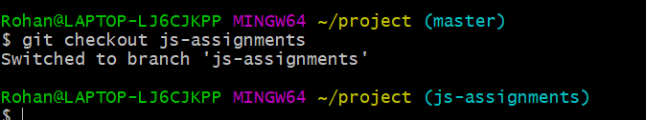

Q3. Copy all JavaScript assignments inside ‘Assignments’ folder.

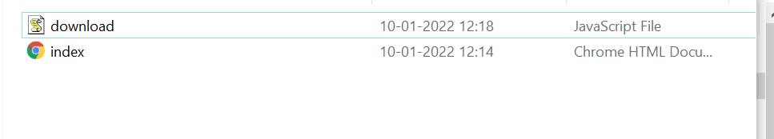

Q4. Commit JavaScript assignments into ‘js-assignments’ branch.

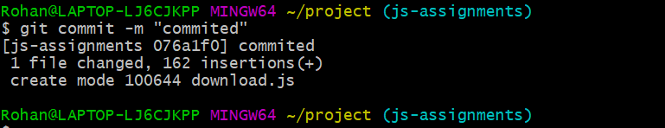

Q5. Make minor changes into README.txt file on line 1 belonging to ‘js-assignments’ branch.

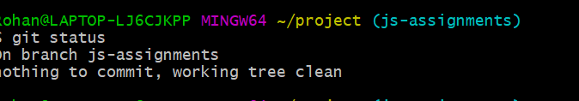

Q6. Commit those changed files.

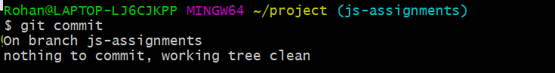

Q7. Switch to master branch.

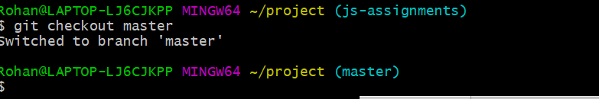

Q8. Make minor changes into README.txt file on line 1 & commit those changes into master.

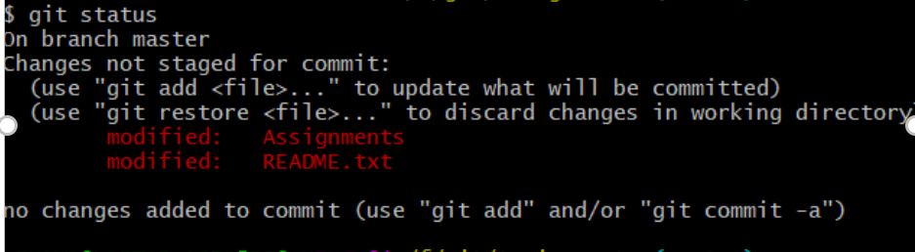

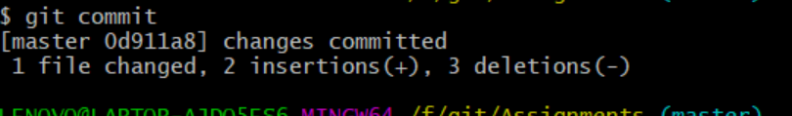

Q9. Again switch to ‘js-assignments’ branch.



Q10. Make minor changes into few files belonging to ‘js-assignments’ branch.

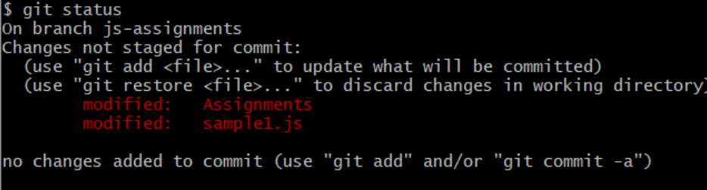

Q11. Commit those changes.



Q12. Switch to master.



Q13. Merge ‘js-assignments’ branch into master. Confirm all JavaScript assignments are shown in master.

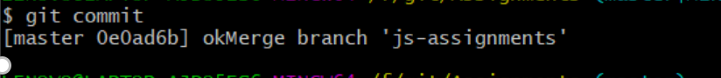

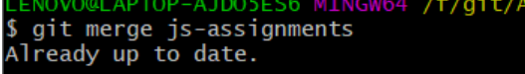

Q14. Finally delete the ‘js-assignments’ branch.

